EXPT NO: 4 | TRANSFER LEARNING USING PRE-TRAINED VISION MODELS FOR IMAGE RECOGNITION
DATE:

PRE-LAB QUESTIONS (PROVIDE BRIEF ANSWERS TO THE FOLLOWING QUESTIONS)
- What is transfer learning in deep learning?
Transfer learning is a technique where a model trained on a large dataset is reused for a new, related task. The learned features are transferred to the new model, reducing training time and data requirements.
- What are the advantages of using pre-trained models over training from scratch?
Pre-trained models require less training time and data, provide better accuracy, and already contain useful features learned from large datasets.
- What is the role of fine-tuning in transfer learning?
Fine-tuning involves training some of the pre-trained model's layers on the new dataset so that the model can adapt its learned features to the specific task.
- Name any three popular pre-trained computer vision models.
• ResNet-50
• AlexNet
• VGG-16
- What is the purpose of Hugging Face and how is it useful in deep learning?
Hugging Face provides a large collection of pre-trained AI models, datasets, and tools. It makes it easier to load, experiment with, fine-tune, and deploy models for tasks such as image classification.

AIM
To implement transfer learning using pre-trained vision models for image recognition and evaluate their performance on real-world image datasets.

SOFTWARE REQUIREMENTS
- Python
- TensorFlow/Keras or PyTorch
- Google Colab
- Hugging Face Transformers
- Kaggle Dataset
- Matplotlib
- GitHub

OBJECTIVES
Students will be able to:
- Understand the concept of transfer learning.
- Apply pre-trained vision models for image recognition.
- Fine-tune models such as ResNet or AlexNet.
- Utilize Kaggle datasets and Hugging Face vision models.
- Compare transfer learning performance with custom CNN models.

PROCEDURE
PART A: DATASET PREPARATION
Perform the following tasks:
- Download an image dataset from Kaggle.
- Load and preprocess the images.
- Split the dataset into training, validation, and testing sets.

PART B: IMPLEMENTING TRANSFER LEARNING
Load a pre-trained model such as:
- ResNet-50
- AlexNet
Replace the final classification layer according to the dataset classes.
Freeze the feature extraction layers.
Compile the model.

PART C: MODEL TRAINING AND PERFORMANCE EVALUATION
Train the transfer learning model.
Record:
- Training accuracy
- Validation accuracy
- Training loss
- Validation loss
- Test accuracy
Visualize:
- Accuracy vs Epoch
- Loss vs Epoch

PART D: USING HUGGING FACE PRE-TRAINED MODELS
Perform the following tasks:
- Load a pre-trained vision model from Hugging Face.
- Perform image classification on sample images.
- Compare predictions with the transfer learning model.
- Document observations and upload the notebook to GitHub.

CODE

# ============================================================
# EXPERIMENT NO: 4
# TRANSFER LEARNING USING PRE-TRAINED VISION MODEL
# IMAGE RECOGNITION
#
# Dataset : TensorFlow Flowers
# Model : ResNet-50
# ============================================================
print("Hariharan V S - 24BAD030")

# ============================================================
# 1. IMPORT LIBRARIES
# ============================================================

import os
import tarfile
import urllib.request

import tensorflow as tf
import numpy as np
import matplotlib.pyplot as plt

from tensorflow.keras.applications import ResNet50
from tensorflow.keras.applications.resnet50 import preprocess_input

from tensorflow.keras.layers import (
Dense,
GlobalAveragePooling2D
)

from tensorflow.keras.models import Model
from tensorflow.keras.optimizers import Adam

# ============================================================
# 2. CHECK TENSORFLOW AND GPU
# ============================================================

print("TensorFlow Version:", tf.__version__)

gpu = tf.config.list_physical_devices("GPU")

print("GPU Available:", gpu)

if not gpu:
print("Running on CPU - using FAST training settings.")

# ============================================================
# 3. DOWNLOAD DATASET DIRECTLY FROM INTERNET
# ============================================================

DATASET_URL = (
"https://storage.googleapis.com/"
"download.tensorflow.org/example_images/"
"flower_photos.tgz"
)

DATASET_FILE = "/content/flower_photos.tgz"
DATASET_DIR = "/content/flower_photos"

print("\nChecking dataset...")

if not os.path.exists(DATASET_DIR):

print("Downloading dataset...")

urllib.request.urlretrieve(
DATASET_URL,
DATASET_FILE
)

print("Download completed.")

print("Extracting dataset...")

with tarfile.open(
DATASET_FILE,
"r:gz"
) as tar:

tar.extractall(
path="/content"
)

print("Dataset extracted.")

else:

print("Dataset already exists.")

# ============================================================
# 4. GET CLASS NAMES
# ============================================================

class_names = sorted(
[
folder
for folder in os.listdir(DATASET_DIR)
if os.path.isdir(
os.path.join(
DATASET_DIR,
folder
)
)
]
)

num_classes = len(class_names)

print("\nClasses:")
print(class_names)

print(
"Number of Classes:",
num_classes
)

# ============================================================
# 5. FAST TRAINING SETTINGS
# ============================================================

IMG_SIZE = (160, 160)

BATCH_SIZE = 32

SEED = 123

EPOCHS = 2

# ============================================================
# 6. LOAD TRAINING DATA
# ============================================================

print("\nLoading training data...")

train_ds = tf.keras.utils.image_dataset_from_directory(

DATASET_DIR,

validation_split=0.20,

subset="training",

seed=SEED,

image_size=IMG_SIZE,

batch_size=BATCH_SIZE,

label_mode="int"
)

# ============================================================
# 7. LOAD VALIDATION DATA
# ============================================================

print("\nLoading validation data...")

val_ds = tf.keras.utils.image_dataset_from_directory(

DATASET_DIR,

validation_split=0.20,

subset="validation",

seed=SEED,

image_size=IMG_SIZE,

batch_size=BATCH_SIZE,

label_mode="int"
)

# ============================================================
# 8. CREATE SMALL TEST SET
# ============================================================

# We use a small part of validation data as test data
# to keep CPU execution fast.

val_batches = tf.data.experimental.cardinality(
val_ds
).numpy()

test_batches = max(
1,
int(val_batches * 0.20)
)

test_ds = val_ds.take(
test_batches
)

val_ds = val_ds.skip(
test_batches
)

# ============================================================
# 9. LIMIT DATASET SIZE FOR FAST TRAINING
# ============================================================

# 100 batches × 32 images = approximately 3200 images maximum.
# The original dataset has around 2936 training images,
# so this effectively uses the complete training portion.

train_ds = train_ds.take(100)

val_ds = val_ds.take(20)

test_ds = test_ds.take(20)

# ============================================================
# 10. PREFETCH DATA
# ============================================================

AUTOTUNE = tf.data.AUTOTUNE

train_ds = train_ds.prefetch(
AUTOTUNE
)

val_ds = val_ds.prefetch(
AUTOTUNE
)

test_ds = test_ds.prefetch(
AUTOTUNE
)

print("\nDataset preparation completed.")

# ============================================================
# 11. DISPLAY SAMPLE IMAGES
# ============================================================

plt.figure(
figsize=(9, 7)
)

for images, labels in train_ds.take(1):

for i in range(
min(9, len(images))
):

plt.subplot(
3,
3,
i + 1
)

plt.imshow(
images[i].numpy().astype(
"uint8"
)
)

plt.title(
class_names[
labels[i].numpy()
]
)

plt.axis("off")

plt.tight_layout()

plt.show()

# ============================================================
# 12. PREPROCESS IMAGES FOR RESNET-50
# ============================================================

def preprocess_data(
images,
labels
):

images = tf.cast(
images,
tf.float32
)

images = preprocess_input(
images
)

return images, labels

train_ds = train_ds.map(
preprocess_data,
num_parallel_calls=AUTOTUNE
)

val_ds = val_ds.map(
preprocess_data,
num_parallel_calls=AUTOTUNE
)

test_ds = test_ds.map(
preprocess_data,
num_parallel_calls=AUTOTUNE
)

# ============================================================
# 13. LOAD PRE-TRAINED RESNET-50
# ============================================================

print("\nLoading ResNet-50...")

base_model = ResNet50(

weights="imagenet",

include_top=False,

input_shape=(
160,
160,
3
)
)

print(
"ResNet-50 loaded successfully."
)

# ============================================================
# 14. FREEZE PRE-TRAINED LAYERS
# ============================================================

base_model.trainable = False

print(
"Pre-trained layers frozen."
)

# ============================================================
# 15. ADD NEW CLASSIFICATION LAYER
# ============================================================

x = base_model.output

x = GlobalAveragePooling2D()(x)

x = Dense(
32,
activation="relu"
)(x)

output = Dense(
num_classes,
activation="softmax"
)(x)

# Create final model

model = Model(

inputs=base_model.input,

outputs=output
)

# ============================================================
# 16. COMPILE MODEL
# ============================================================

model.compile(

optimizer=Adam(
learning_rate=0.0001
),

loss=(
"sparse_categorical_crossentropy"
),

metrics=[
"accuracy"
]
)

print("\nModel compiled successfully.")

# ============================================================
# 17. DISPLAY MODEL SUMMARY
# ============================================================

print("\nModel Summary:")

model.summary()

# ============================================================
# 18. TRAIN MODEL
# ============================================================

print("\n======================================")
print("STARTING TRAINING")
print("======================================")

history = model.fit(

train_ds,

validation_data=val_ds,

epochs=EPOCHS
)

# ============================================================
# 19. TEST MODEL
# ============================================================

print("\n======================================")
print("EVALUATING MODEL")
print("======================================")

test_loss, test_accuracy = model.evaluate(
test_ds
)

print("\n======================================")
print("FINAL RESULTS")
print("======================================")

print(
"Test Loss :",
test_loss
)

print(
"Test Accuracy :",
test_accuracy
)

# ============================================================
# 20. ACCURACY VS EPOCH
# ============================================================

plt.figure(
figsize=(8, 5)
)

plt.plot(
history.history["accuracy"],
marker="o",
label="Training Accuracy"
)

plt.plot(
history.history["val_accuracy"],
marker="o",
label="Validation Accuracy"
)

plt.title(
"Accuracy vs Epoch"
)

plt.xlabel(
"Epoch"
)

plt.ylabel(
"Accuracy"
)

plt.legend()

plt.grid(True)

plt.show()

# ============================================================
# 21. LOSS VS EPOCH
# ============================================================

plt.figure(
figsize=(8, 5)
)

plt.plot(
history.history["loss"],
marker="o",
label="Training Loss"
)

plt.plot(
history.history["val_loss"],
marker="o",
label="Validation Loss"
)

plt.title(
"Loss vs Epoch"
)

plt.xlabel(
"Epoch"
)

plt.ylabel(
"Loss"
)

plt.legend()

plt.grid(True)

plt.show()

# ============================================================
# 22. SAMPLE PREDICTIONS
# ============================================================

print("\nGenerating sample predictions...")

plt.figure(
figsize=(12, 8)
)

for images, labels in test_ds.take(1):

predictions = model.predict(
images,
verbose=0
)

predicted_classes = np.argmax(
predictions,
axis=1
)

for i in range(
min(9, len(images))
):

plt.subplot(
3,
3,
i + 1
)

# Reverse ResNet preprocessing
image = images[i].numpy()

image = image + np.array(
[
103.939,
116.779,
123.680
]
)

# BGR → RGB
image = image[:, :, ::-1]

image = np.clip(
image / 255.0,
0,
1
)

plt.imshow(
image
)

actual = class_names[
labels[i].numpy()
]

predicted = class_names[
predicted_classes[i]
]

plt.title(
"Actual: " + actual +
"\nPredicted: " + predicted
)

plt.axis("off")

plt.tight_layout()

plt.show()

# ============================================================
# 23. SAVE MODEL
# ============================================================

MODEL_PATH = (
"/content/"
"resnet50_transfer_learning_flowers.keras"
)

model.save(
MODEL_PATH
)

print(
"\nModel saved at:"
)

print(
MODEL_PATH
)

# ============================================================
# 24. FINAL OUTPUT
# ============================================================

print("\n======================================")
print("EXPERIMENT 4 COMPLETED")
print("======================================")

print(
"Dataset : TensorFlow Flowers"
)

print(
"Model : ResNet-50"
)

print(
"Classes :",
num_classes
)

print(
"Image Size :",
IMG_SIZE
)

print(
"Batch Size :",
BATCH_SIZE
)

print(
"Epochs :",
EPOCHS
)

print(
"Test Accuracy :",
test_accuracy
)

print("======================================")

OUTPUT
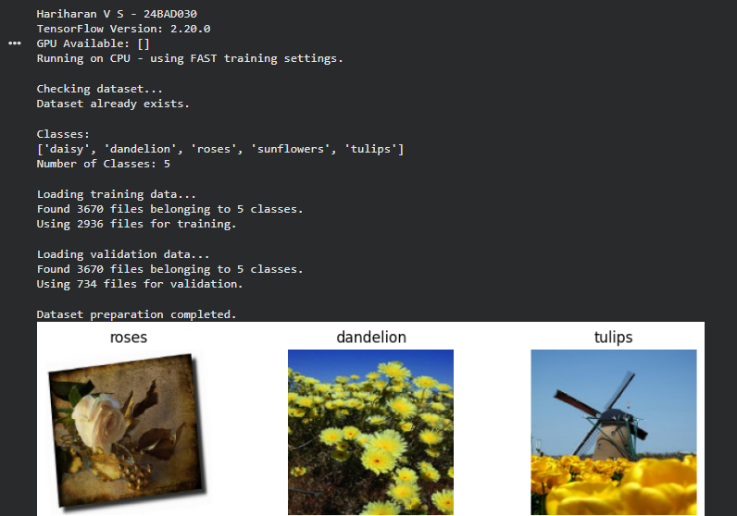

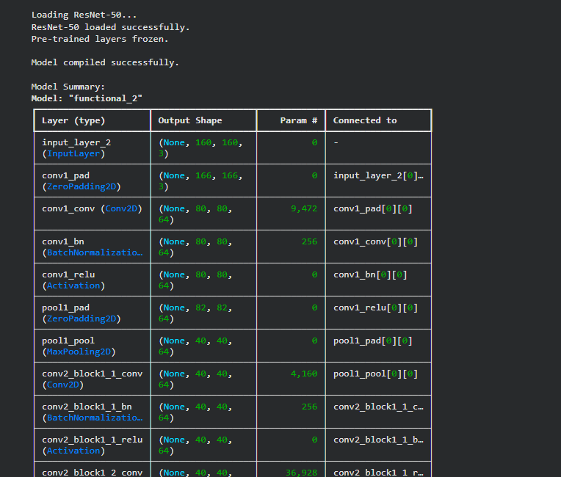

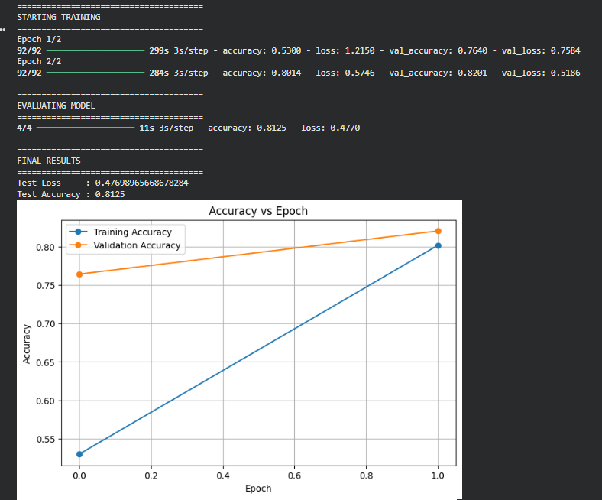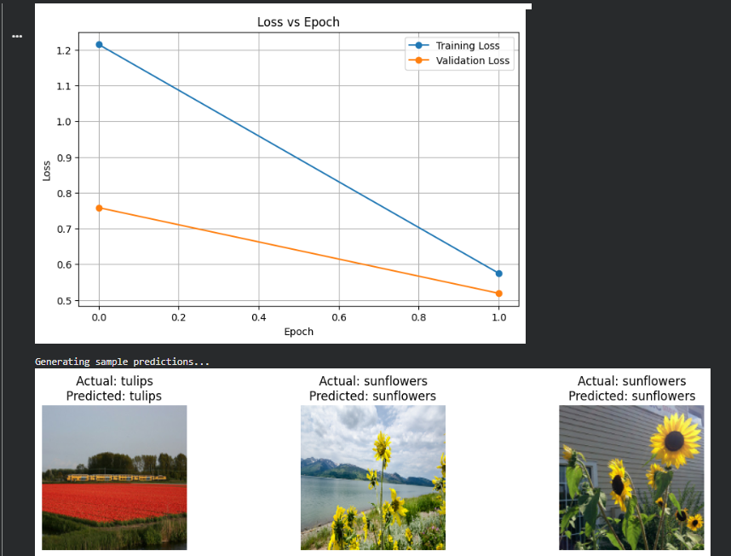

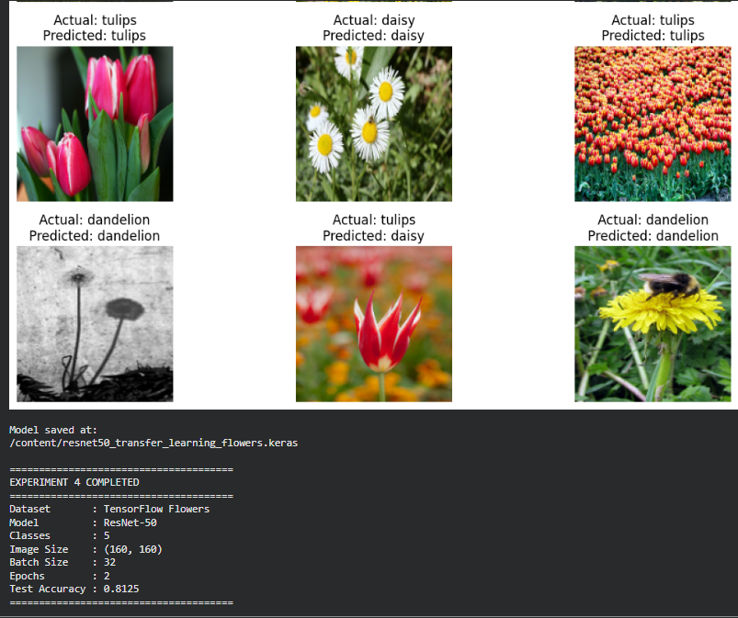

EXPECTED OUTCOME
Students will understand the advantages of transfer learning and gain practical experience in fine-tuning pre-trained vision models from TensorFlow/PyTorch and Hugging Face for image recognition tasks.

POST-LAB QUESTIONS (PROVIDE BRIEF ANSWERS TO THE FOLLOWING QUESTIONS)
- What are the advantages of transfer learning compared to training a CNN from scratch?
Transfer learning provides faster training, requires less data, reduces computational cost, and often achieves higher accuracy than training a CNN from scratch.

- Why are pre-trained models able to achieve higher accuracy with fewer training epochs?
Pre-trained models have already learned useful features such as edges, shapes, textures, and patterns from large datasets. Therefore, they need fewer epochs to learn the features specific to the new dataset.

- Compare the performance of the transfer learning model with the CNN implemented in the previous experiment.
The transfer learning model generally performs better than a CNN trained from scratch because it starts with previously learned features. It usually reaches higher validation and test accuracy in fewer epochs.
- What is the purpose of freezing layers during transfer learning?
Freezing layers prevents their weights from being updated during training. This preserves the useful features learned from the original dataset while only training the new classification layers.
- How can Hugging Face simplify the deployment and experimentation of vision models?
Hugging Face provides ready-to-use pre-trained vision models and easy-to-use libraries. This allows users to quickly load models, perform image classification, compare predictions, and experiment without building models from scratch. The experiment specifically asks students to load a Hugging Face vision model and compare its predictions with the transfer-learning model.

ASSESSMENT
Description | Max Marks | Marks Awarded
Pre Lab Exercise | 5
In Lab Exercise | 10
Post Lab Exercise | 5
Viva | 10
Total | 30
Faculty Signature

